COMPARING THE WEATHER LOCALLY THIS WINTER WITH LAST WINTER (any season may be used).

Age group: senior classes -primary school.

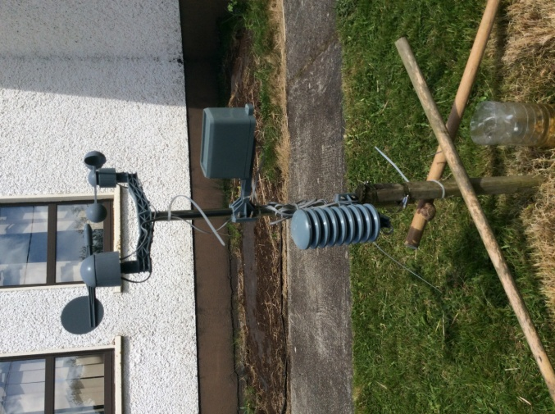
Objectives:
- To enable the children to become familiar with the workings of the school weather station
- to encourage the children to collect weather data on a daily basis
- to enable the children to design suitable tables to record the data
- to enable the children to represent the data in Excel
- to analyse the data in terms of the total, the mean, the mode , the median and the range
- to draw conclusions and comparisons from the data collected
- to make an animation of an aspect of the findings
- to design and build a robot with weather sensors
- to create scratch projects to represent the findings
- to contribute to the STEM for all seasons weather blog
- to investigate various climate phenomena
- to use the Arduino board to programme temperature sensors
- to create Powerpoint presentation on the various aspects of the weather
- to present findings in Sway

Content:

Set up the weather station:
- Decide on the type of weather station to buy
- Decide on a suitable location so the data collected would be reliable
- Set up the station.

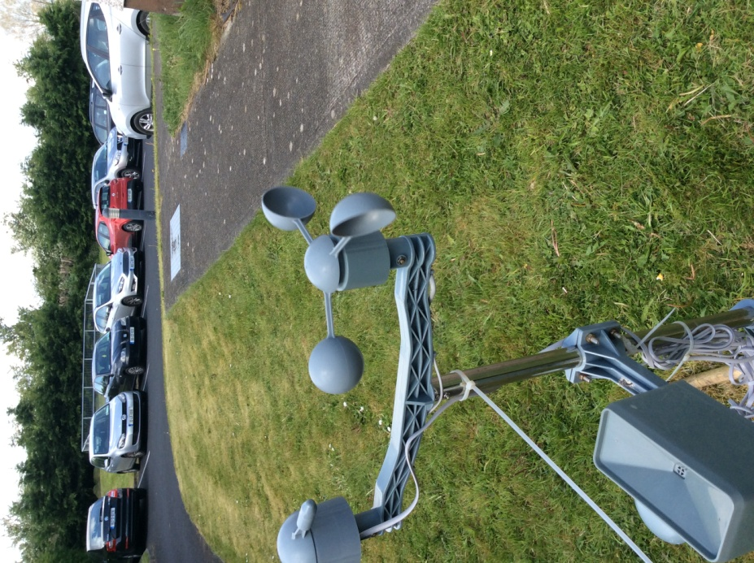
Make predictions:

- Invite the students to made predictions - decide on the parameters for the predictions with the class e.g. sunnier, colder, warmer, wetter, windier more humid than last winter
- Collate the findings
- Calculated the percentages for each prediction
- Represented the findings on a pie chart

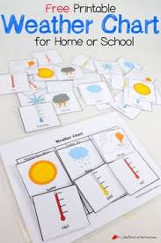

Record the weather data on a daily basis:

- Design a suitable table to use to record the information collected
- Decide on what information to collect
    - maximum daily temperature
    - minimum daily temperature
    - lowest daily grass temperature
    - rainfall in millilitres
    - wind speeds
    - when wind gusts exceeded 34 km
    - sunshine hours
    - the warmest time of the day
    - the coldest time of the day
    - the wettest time of the day
- record on a daily basis the weather information for temperature rainfall wind sunshine hours and grass temperatures.

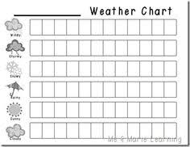

Present the data collect:

- Using the data collected for November /December 2016/2017 draw graphs using excel
- decide on the best type of graph to represent the data collected
- bar chart
- trend graph
- pie chart
- bar line graph

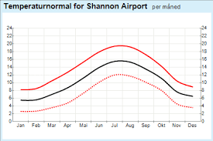
Compare data collected and draw conclusions:
- using the graphs and the data collected set about drawing conclusions
    - maximum daily temperature
    - minimum daily temperature
    - lowest daily grass temperature
    - rainfall in millilitres
    - wind speeds
    - when wind gusts exceeded 34 km
    - sunshine hours
    - minimum grass temperatures
Write up the findings in detail.

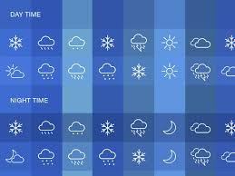

Making and designing:

- study the weather instruments used to measure the different components that make up weather
- each student designed and made a weather instrument
- refer to the specific lesson plan on this
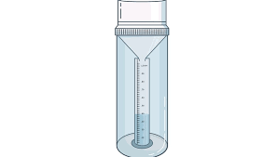
Group project work:

- students working in groups selected a weather related topic and designed PowerPoint presentations on their chosen topic
- Present these projects to the class and at assembly
- topics may include
  - weather instruments
  - how to read a weather chart
  - clouds
  - different forms of precipitation
  - sunshine
  - rain
  - the water cycle
  - the Beaufort scale
  - the Met Eireann weather warning system
  - climate change and the marine environment.
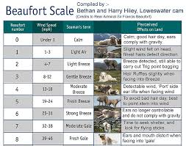

Technology:

- Build Scratch projects to show the weather findings
- Design and build a robot to crush ice and to travel over rough and icy terrain
- Design and build a robot to pick up litter to reduce pollution and so reduce climate change.
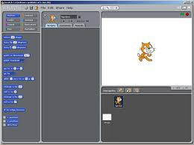

Animation:

- Using One stop motion created an animation to represent the findings
- design the story board
- build the necessary elements using clay etc
- write a rap to go for the animation

Presentation of findings:
- Present the findings on the website STEM for all seasons
- Present findings at the school assembly.
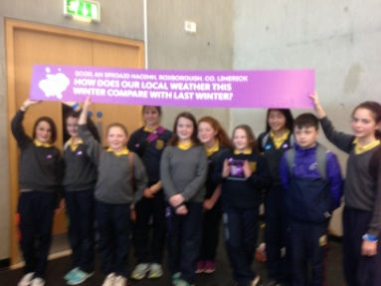

Assessment:
- Teacher observation
- teacher designed tasks
- portfolio assessment
- concept mapping.

