Climate Change And The Marine Environment

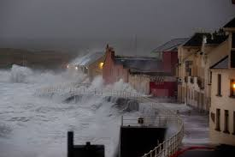

Age group: Senior classes primary school

Objectives:

- to enable children to source local weather data going back a number of years
- to encourage the children to represent this data in an accessible format
- to apply mathematical formulas to the data
- to enable the children to interpret the data and draw conclusions
- to enable the children to become familiar with the concept of climate change
- to familiarise the children with and to investigate the causes of climate change
- to explore the impact of climate change on the marine environment
- to investigate ways we might halt or at least reduce climate change
- to represent the information learned on scratch, in an animation and in Powerpoint presentations
- to build a robot that would help with cleaning the beech
- to present the information learned in a variety of forums

Content:

Collection of local weather data:

Visit the website of the local weather station and download the monthly weather records going back a number of years (http://www.met.ie/climate/monthly-weather-reports.asp).
Divide the class in pairs and assign each pair a specific month.
Encourage the children to design an appropriate table to record the weather data relevant to
- sunshine hours
- rainfall
- highest temperature
- lowest temperature
- wind gusts in excess of 34km
- any interesting weather event(s) for the particular month
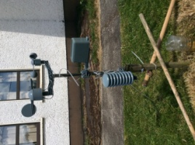

Presentation of weather findings:

Using Excel represent the data collected in graph format. Encourage the children to select the appropriate type of graph to use.

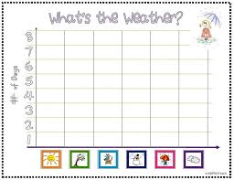

Analysis of weather data:

Analyse the data collected and draw conclusions.
Encourage the children to pay close attention to changes in climate data over the period in time selected
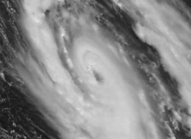

Calculate the following where appropriate:
- total
- mean
- median
- mode
- range

Drawing conclusions:

Present the findings to the class
Using the findings collate a clear picture of changes in the weather locally.

Climate change:

Enable the children to understand what is meant by Global warming.

Causes of climate change:

Encourage the children to research the topic of climate change and to identify the underlying causes.
Encourage the children to focus on the following
- burning fossil fuels
- cutting down forests
- increased CO² emissions
- breeding huge numbers of cattle
- greenhouse gases
Using Scratch and Powerpoint presentations encourage the children to present what they have discovered and learned.
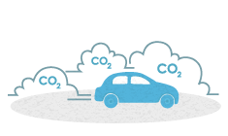

Explore the many threats to our oceans:

- over fishing
- oil spills
- pollution
- climate change

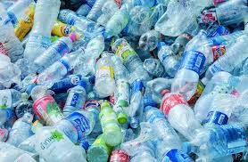

Investigate the impact of climate change on the marine environment:
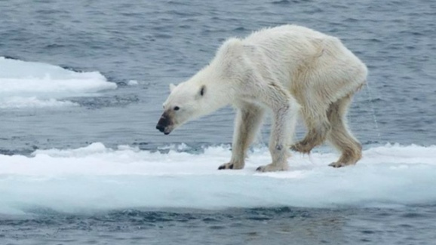

- coral bleaching
- melting ice caps
- rising sea levels
- increased flooding in coastal areas
- islands being submerged
- marine species losing their homes, food and nesting environments
- new marine species off our shores
- impact of acidic water on shellfish
- increased coastal erosion as a result of the increase in stormy weather
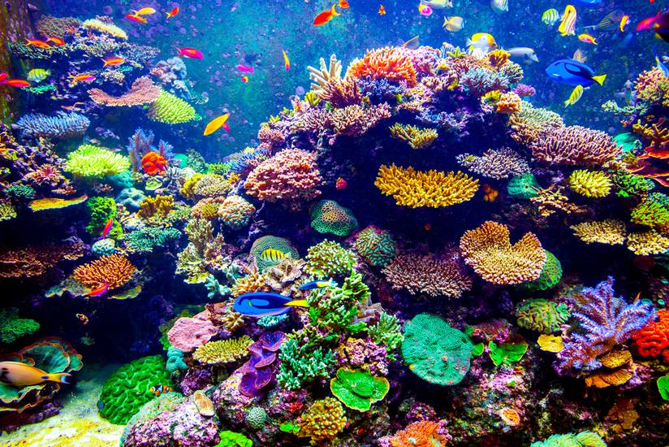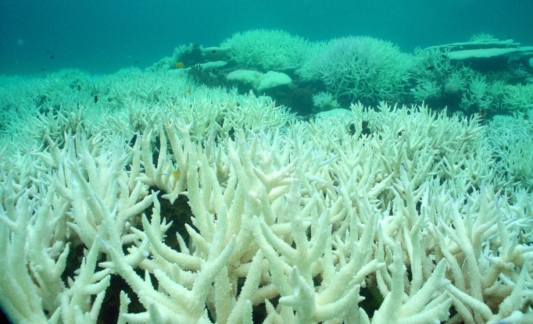

Create an animation:

Encourage the children to develop an animation that clearly represents the impact that climate change has on our oceans.
The children build a story line for the animation
Using clay the children construct the characters and items necessary for the animation
Encourage the children to work in groups and write an appropriate rap for the animation.
Using One stop carefully construct the story board
Edit and add the rap and background music

Investigate the actions we might undertake to offset climate change:

Encourage the children to investigate and then implement a range of changes they can undertake to offset the impact of climate change.
- walk or cycle to school
- car pool or use public transport where possible
- buy local
- grow vegetables
- plant a wild flower garden
- plant more trees
- be energy efficient - turning off lights etc.
- reduce, reuse, recycle and upcycle
- conserve water
- eat less red meat do a two minute beach clean
- create awareness and get as many involved in the project as possible
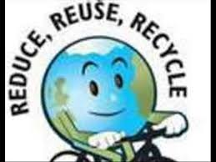
Upload the animation the children have made on the impact of climate change on the marine environment on the school website to create awareness.
Explore other ways children might create awareness of the actions they may undertake.

Build a robot: The Beach Cleaner

Provide the children with the opportunity to design, build and programme a robot capable of picking up and properly discarding rubbish found on the beach.
Brainstorm with the children how best to approach this task.
To complete the process of building the robot divide the children into groups
- materials team
- design team
- build team
- programming team
- operating team
- PR team
Test out the robot, trouble shoot and re design where appropriate.

Presentation of project:
Provide the children with opportunities to present and display their work.
- Scratch
- Powerpoint presentations
- website
- Animation
- school assembly and notice board
- local and national conferences and events
- weather blog

Encourage the children to display their findings on the school website and at local events.

Assessment:

Assessment of the lessons will be ongoing. Each stage will be dependent on the successful completion of the previous stages so the children will to a large extend have to assess their own work in order to progress

