school festival: the Glubschi – weather - show class 4 a
Assist:
- in stem subjects: theme water cycle (as in the curriculum), various types of
precipitation, weather, weather signs, weather maps, weather predictions

Idea: We make a weather prediction for the school festival
- With small films on the subject of weather (self-directed)
- main actors: Glubschis (cuddly animals with big eyes, the class just collects)

preparation:
- Students choose a weather category and collect information about them in groups. They create material posters (topics chosen: wind, sun, rain, thunderstorm, clouds) and introduce them.
Execution:
In the group, students create short film-books on the topic, distribute roles, get and craft props, choose a background (for the “kasperltheater”), consider special effects (background music, light effects, wind effects, etc.)
- Practice the drain without taking up
- Project Day: Recording: single groups play their scenes, filmed with Ipad
- Minimum post-processing of the individual films by L, SS (IMovie)
Reflection:
- Reflection in learning diary entry: What I learned about filming.
Continuation:
- Writing a moderation text by L / SS
- Create a PowerPoint presentation (L / SS together)
- Practice the presentation with various moderator teams and assistants
- Creating a timetable for the school festival (4 dates)

school festival: The musical weaterforecast of the class 4 a
Preparation: see above

Idea: Parallel to the Glubschi weather prediction to present the prediction with music

Preparation:
- Choosing suitable musical pieces to the weather categories as medley:
Thunderstorm: ACDC
Wind: Rock you like a hurricane: Scorpions
Clouds: Purple Clouds: Materia
Sun: Like ice in the sunshine (Advertisement)
Rain: It`s raining men: Weather girls
- writing a suitable German text on the subject
- to divide the soloists
- Creation of choreographies (eg with instruments / requesters), recording on flipchart
- practicing the choreographies in the gym, practicing the change of songs
- Practice the songs with solists in the classroom

Performance:
- At the school festival, in the gym, with moderation by 2 pupils

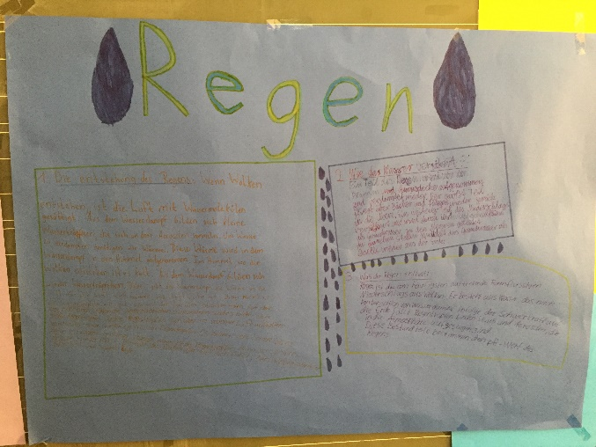
weather posters:
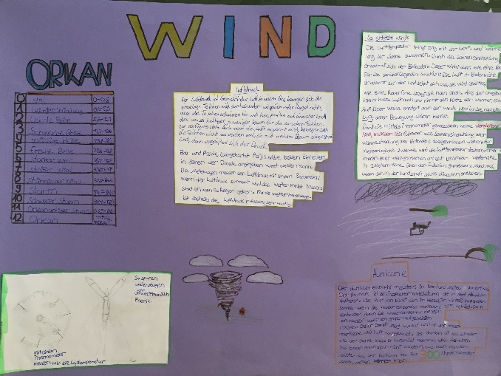

video shoot:
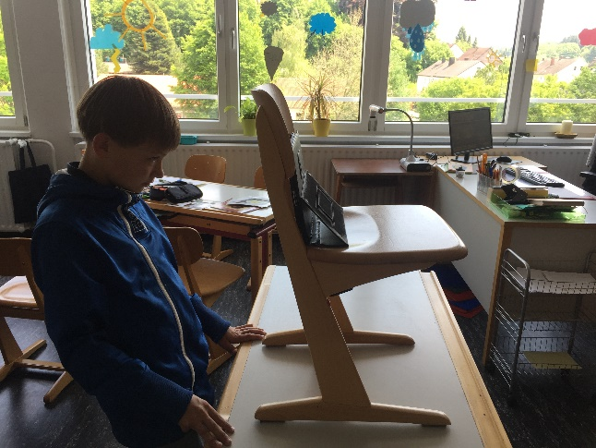
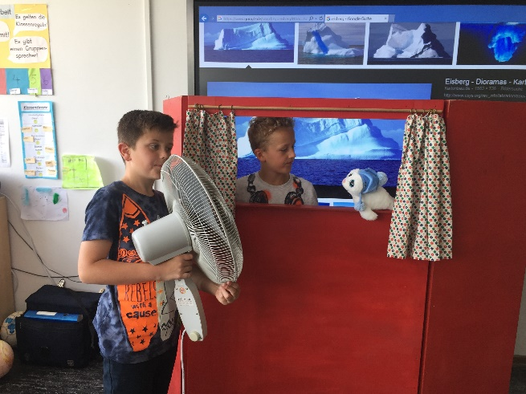

weathershow at schoolfestival:
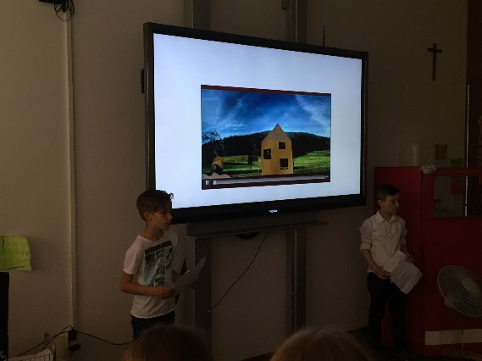
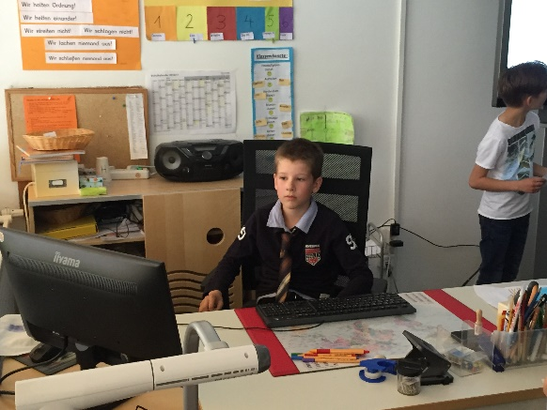

Hello!
Welcome to the Glubschi-Show
On the subject
The Glubschis experience the weather!
Before we begin, let us first explain how the Glubschi show came about.
We, class 4 a, have passed the water cycle and the weather in home and technical teaching.
Since this is also the topic of the Erasmus project of the school and this has something to do with new media, we came up with the idea to shoot small films.
In these films the weather is illustrated and explained. And since the small stuffed animals of Glubschi are up to date, we have made them the main characters of our films.
And so the films were created:
In groups, we have written scripts and made props. For example, The two main actors of the cloud film grandpa JACK and fish Nomo.
The school was played behind the old puppet theater. But the background was made with our new touchboard.
The props, however, had to be tampered, as here for example. ----------------------------
We have also incorporated a few special effects, e.g. With this here (fan) or these instruments (thunder).
For a morning we filmed with a tablet. It was quite exhausting. We had to concentrate very much and we did several shots.
In the end, our computer specialist Tim K. has worked on the films, for example. The sound made louder or small noises inserted.
So be careful when you see the movies. You can rediscover some!
And now have fun with the Glubschi- Show

Translatet Lyrics of the musical weather forecast (sung in German)
thunderstorm
It is sultry, it is dark, soon comes the night.
Wind refreshed and a low thunder was already crashing.
And in the sky dark clouds are spreading.
Take care, because it is very soon already so far.
Rain and wind
Lightning in the sky
Rain and wind
Lightning in the sky
Can you hear him
thunderclap
thunderclap
Hurricane
When the wind blows heavily over the Atlantic
It swirls the water, the air turns.
With great strength like a hurricane
A tropical storm is coming.
The waves they hit really high
It's still raining
The storms have names, but they are not nice,
They are very dangerous, in the Zyklonenduet
Now begins
Here a wild whirlwind
Now begins
Here a wild whirlwind

Purple clouds
Thirty degrees, I cool my head
At the window glass on the Zeitlupenkopf
We live always faster, celebrate hard
We meet the friends and forget our day
Do not want any stress, no pressure, take a sip
From the Cola, look into this heaven, as from Hollywood
Red pops into the blue, gilds our city
And over us purple clouds pull into the night
We stay awake until the clouds are purple again
We stay awake until the clouds are purple again
(Oh oh) the clouds are purple again
We stay awake, the clouds are purple again
Look up there a new star (yeah)
Can you see him at our fireworks? (Oh)
We tear ourselves away from all threads (yeah)
Let her sleep, come, we take off
Sun
We love the sun
We love the sun
At Sunshine
Often to be outside
We love the sun,
We love the sun,
at Sunshine,
To be outside.
If it's quite warm outside
And the sun shines beautiful.
We dance together
And we are all united here....
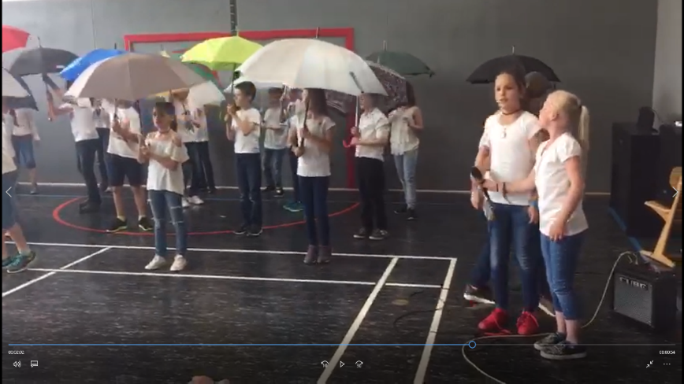
rain
Hey, we're the weathergirls
And we have news for you
Get ready, all of you here
And leave your umbrellas at home
The school festival begins,
The mood is famos,
The children and parents are here,
The same is really happening.
Because today is about the weather
For the first time
And we tell you how it is today
The weather will be ideal
It is not raining! Certainly not!
It is not raining! No! No!
Can celebrate outside and sit long
The children get away with the time.
It is not raining! Certainly not
It is not raining! No No!
Warm, dry, and without wind
Weather reports are always correct.
In Slovenia, Portugal, Ireland, and also Greece
If our weather report at Erasmus is known all over Europe,
Here you get the weather prediction, guaranteed
False reports have not happened to us yet.
It is not raining! Certainly not!
It is not raining! No! No!
It is not raining! Certainly not!
It is not raining! No! No!

