We build a wind chime
The students build a wind chime.
1. material: - clay pots (diameter ca. 7cm)
- school colour, protection paint
- brush, cotton swab
- craft cord, wood beads (diameter ca. 1cm), larger wooden beads (diameter ca. 1,5 cm)
2. workplace: - underlay (e.g. newspaper)
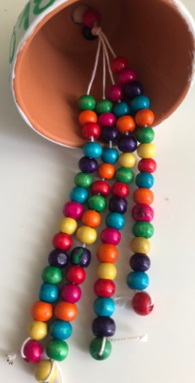
3. operation:
- Students prime their clay pot in one or more colors.
- During the drying time the students thread 16 wooden beads on 4 strings and knot them.
- The 4 cords with the wooden beads are then knotted together.
- The dried clay pot can then be decorated with cotton swabs or a fine brush.
4. completion:
- The clay pot is finally covered with a protective varnish so that it can be hung outside.
- The cords with the wooden beads are then attached to the finished clay pot using a larger bead.
- When there is sufficient wind, the beads move, knocking against the pot and sounding.

