Erasmus + STEM For All Seasons
School festival: Weather stations - on 19.05.17
--------------------------------------------------------------------------------------------------------------------------
Theme: Recognize and assign water and weather sounds
Good listening is an important prerequisite for speaking, reading and writing. Various water and weather sounds on a CD train the exact listening. An image card must be assigned to each sound. This is a tricky task not only for children, but also for adults. The pupils worked, partly with their parents and siblings, alone, in pairs or in groups.

- Introduction and explanation
"You'll find an envelope with 14 pictures on your table. You will hear different water and weather sounds one after the other. Put the picture cards in the order of the noises. If you're not sure, leave a leak and decide at the end. "

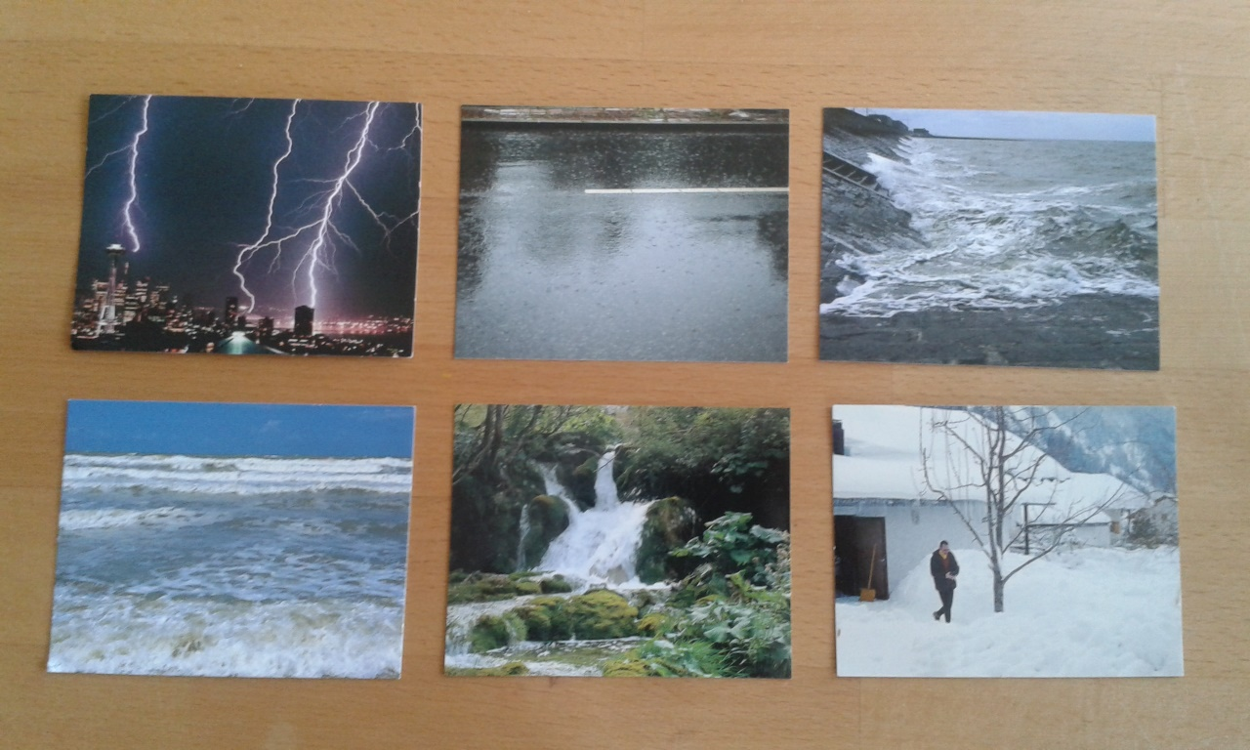

- Listen and assign

- Resolution
"Now turn your picture cards. You will find a number on each. If you have heard correctly, your numbers are the same as those on the blackboard. "

Material:
CD with 24 water sounds and picture cards (10 times duplicated)
"Wassergeräusche Spiel", Verlag an der Ruhr, www.verlagruhr.de

