Name:___________________
Erasmus + „STEM FOR ALL SEASONS“ Projekttag am 9.11.2017

Autumn
Mathematics: Fermi- Task: Pile of Leaves
A favorite task of the Italian physicist Enrico Fermi (1901-1954) was to estimate things that can not be counted. The solution should be found through clever considerations.

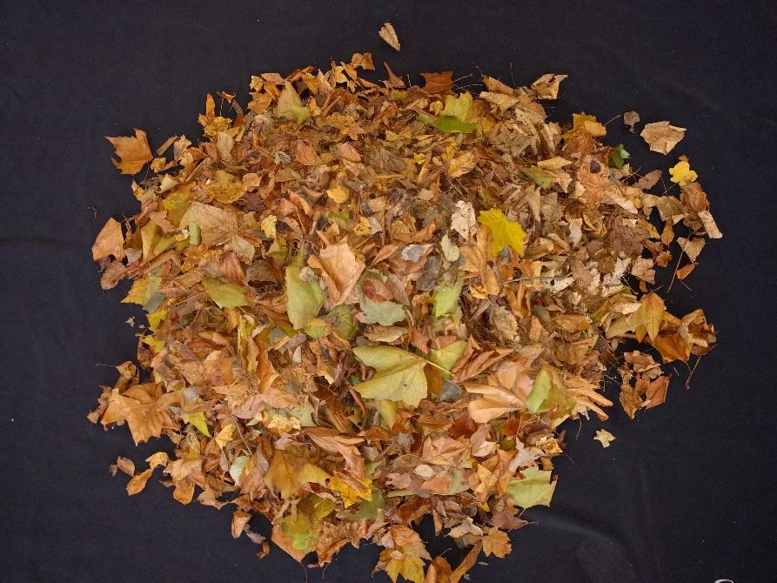

How many leaves are in the pile of leaves?
1. What do you think!
It's about ________________ leaves.

2. How many leaves are there really?
Think and calculate!
Write down your solution proposal!

Tips for help:
Possibility number 1:
Divide the pile into 2 pieces /4 pieces/… until the pile is so small that you can count it.
Then double your number until the pile is together again.

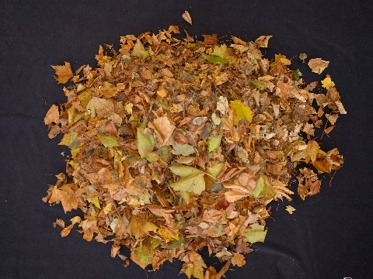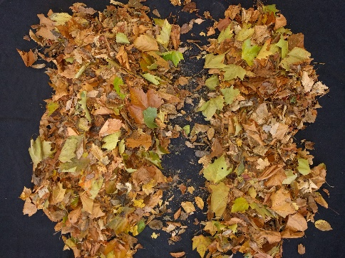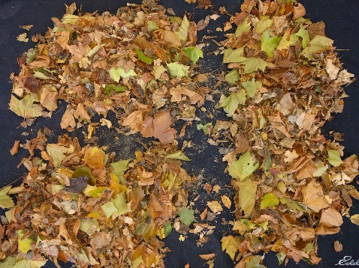

Possibility number 2:
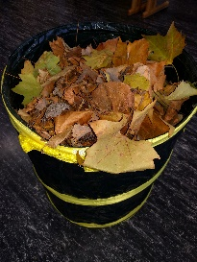
Weigh a counted number of leaves.
Weigh the whole pile => divided by the number of leaves

Possibility number 3:
All the children in the class take leaves and count. In the end, add up the results

Material:
- Scales
- Bags / big garbage bag

Informations for teachers

Fermi- tasks
(https://kira.dzlm.de/mathe-mehr-als-ausrechnen/prozessbezogene-kompetenzen-f%C3%B6rdern-beispielaufgaben/fermi-aufgaben)

Fermi assignments are named after the Italian nuclear physicist and Nobel Prize winner Enrico Fermi (1901-1954), who was known to be interested in his students' ability to think and ask strange questions. The best known is his question: "How many piano tuners are there in Chicago?".
Fermi tasks are realistic, accessible and open; they foster skills such as exploring, flipping, working with big numbers, converting sizes, taking advantage of everyday knowledge, arguing, communicating, being self-reliant, and applying heuristic strategies; they challenge; they stimulate further thinking and open the view for mathematics in the world (see Wälti 2005, pp. 34-38) - even though one is usually not confronted with such tasks in reality.
Characteristic of this type of task is, inter alia .:
• At first it seems to be an insoluble problem that one has to get involved in to solve it.
• Lack of information must be gained from assumptions, everyday situations, guessing, guessing, flipping, looking up or consulting with experts.
• You have to work with large numbers or often with the conversion of quantities.
• There are no clear indications and solutions, let alone "the right or wrong solution", so that the solution found must be plausibly substantiated and procedures explained.
• Results must be reviewed, compared and evaluated.
(vgl. Wälti 2005, S. 34-38; Bongartz & Verboom 2007, S. 146-149)
The calculation itself thus takes a back seat. The emphasis is rather on the steps before and after arithmetic such as estimating, measuring, researching, translating into the language of mathematics, finding different ways and interpreting and evaluating the results. Notes on using Fermi tasks in the classroom. In particular, because Fermi tasks are very open, it is the responsibility of the teacher to prepare well. You should therefore think about ...
• whether there are any terms or factual content that she must discuss with the children beforehand.
• what ideas the children could have for the solution process and what they might need for it.
• which literature and which material she provides to the children.
• which rooms / places the children can use to find solutions.
• How it supports children who have no ideas and / or can not find a solution.
(vgl. Bongartz & Verboom 2007, S. 146-149)
Even though Fermi tasks certainly rarely represent realistic fact-based computing, it is still worthwhile to use these tasks in the classroom, since dealing with such tasks demands and encourages a variety of content-related and process-related skills

Trees
How many leaves does a tree have?
https://de.wikipedia.org/wiki/Baum

Why do leaves lose their leaves in autumn?
Video 2.06 min
https://www.youtube.com/watch?v=mkZYPJ7pDto
http://www.naturdetektive.de/natdet-201243_baeume-herbst0.html

Solutions of children

Group 1
• A child immediately started counting -> stopped at 23. "It takes forever, until we have counted!"
• Idea: All in the group count 23 leaves => painting task: 23 leaves x 17 children
• It is easier to calculate with 25 sheets => 4 x 25 = 100 => 18x 100 = 1700
• The counted pile was slightly more than half of all the leaves => in the pile are about 3000 leaves

Group 2
• See option 1 Suggested help

Group 3
• See option 1 Suggested help

Group 4
• See Group 1: Each child has 30 leaves counted

Group 5
• See option 3 help suggestion

Group 6
• See option 2 Suggested help

