Weather Lesson: Storm Names and Weather Warnings
Learning Outcomes:
- Familiarising pupils with the naming of Atlantic storms.
- Enabling pupils to create their own list of storm names.
- To understand the warning levels associated with storms.
- To use digital technology for pupils to design their own weather warning systems.
- Why Weather Warnings:
Our Met office ( MET Eireann) issues weather warnings if they feel the public needs to be alerted to potentially dangerous weather conditions.
Weather warnings are issued so minimized damage to property and disturbance to economic activity and to protect and save the lives and livelihoods of our citizens.
Categories of Weather Warnings:
- Status Yellow: Be Aware
- Status Orange: Be Prepared
- Status Red: Take Action.

- Each Category Explained.
- Status Yellow: The yellow warning is to allow people time to take preventative action. Level yellow warnings are given when conditions do not pose an immediate threat to most people.
- Status Orange: In the case of an orange weather warning weather conditions have the capacity to impact significantly on people. Recipients need to prepare themselves for the expected weather conditions.
- Status Red: A red weather warning is a severe weather alert. Recipients neeed to take action to protect themselves and their property.
Active learning Activity : Using Explain Everything Create a weather warning system using the App – Explain Everything.

Naming Atlantic Storms has come into effect since 2016.
Met Éireann (our meteorological service) and the British Met Office launched a campaign to increase awareness of extreme weather events.
If a storm is considered to have the potential to have a medium or high impact on Ireland or the UK.
Weather systems where an amber warning is expected to be issued will get a name.
Members of the public have a say and can submit names which are released in Autumn each year.
Names submitted are Christian names and are in alphabetical order.
The names alternate between male and female names.
Letters such as Q, U, X, Y or Z are not used.
Storms which are associated with loss of life are not used and are retired. 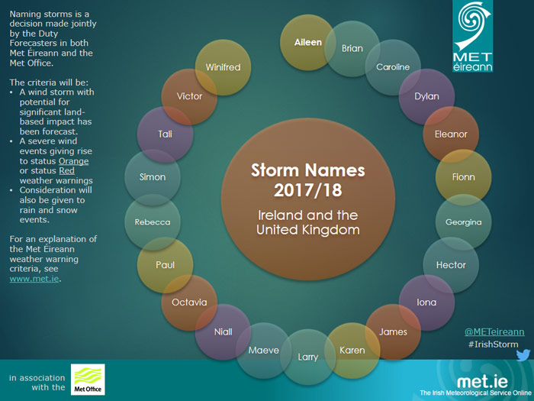

These are the storm names for the 2017/1018 season.
Make:
Make your own list of storm names using your classmates’ names for next season.

Don’t forget it has to be alphabetical and boy, girls etc.

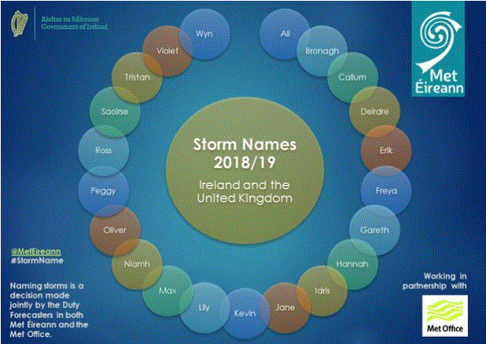
Here are the names for the 2018-2019 season.

